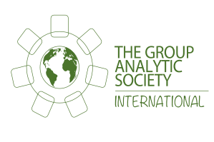
SECOND ANNOUNCEMENT

44th Autumn Workshop followed by AGM & Large Group

Friday 9th and Saturday 10th November 2018
London, UK

Large Groups: Contemporary Challenges

Chairs:
Carla Penna and Linde Wotton

Lecturers:
Earl Hopper and Teresa von Sommaruga Howard

Participants’ Panel: Contemporary Applications

Large group conductors:
Göran Ahlin & Jale Cilasun

Saturday afternoon: AGM & Large Group

3 Large Groups over 2 days

Venue: Coin St Neighbourhood Centre
South Bank, SE1 9HN
Nearest underground station: Waterloo

Full programme and registration to follow

Group Analytic Society Phone: +44(0)20 7435 6611 Contact:
1 Daleham Gardens www.groupanalyticsociety.co.uk Julia Porturas
London NW3 5BY E-mail: office@groupanalyticsociety.co.uk Administrator

